Ideation Phase
Empathize & Discover

Date | 20 February 2026
Team ID | LTVIP2026TMIDS70689
Project Name | HouseHunt: Finding Your Perfect Rental Home
Maximum Marks | 4 Marks

Empathy Map Canvas:
An empathy map is a simple and easy visual that captures user behaviours and attitudes. It helps the team understand users and their problems. This empathy map is prepared for the HouseHunt project to understand people searching for rental houses.

User Type:
• Students
• Families
• Property owners

Empathy Map Diagram:
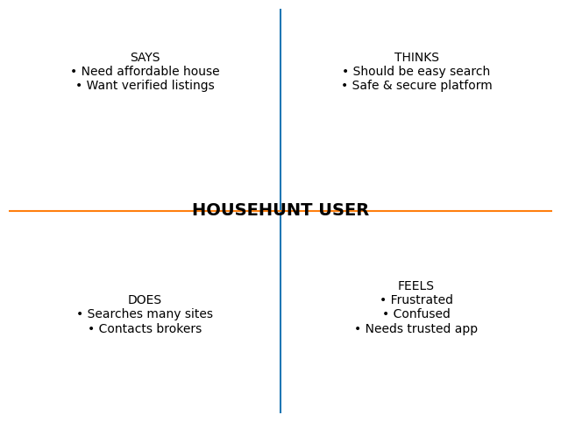

Understanding from Empathy Map:
Users want a simple and trusted platform to search houses easily, compare prices, and contact owners directly. The HouseHunt system is designed to solve these problems.

